**Final Project Proposal**

**Toronto Safety Assessment by Year, Crime Type, and Neighborhood**

* Presented by George Redak, Jim Tran, Sharifah Sinclair, Vena Li

**Question**

Based on the crime severity and frequency, what are the safest neighbourhoods in Toronto.

Are crime types an indication of neighbourhood income?

Does time of day affect the type of crimes that occur?

Does avg income of an area have an influence on the type of crime/frequency?

**Data needed**

Crime Data (opentoronto)

* API
* Download document
* <https://data.torontopolice.on.ca/pages/open-data>

Neighbourhood data?

* <https://open.toronto.ca/dataset/neighbourhood-profiles/>
* <https://open.toronto.ca/dataset/neighbourhood-crime-rates/>

**Visualization**

(we should get a really good dashboard layout for this)

<https://usebootstrap.com/preview/adminlte-v3>

Colored map

<https://data.torontopolice.on.ca/pages/maps>

<https://torontops.maps.arcgis.com/apps/webappviewer/index.html?id=7a0da718559648b8a1146ecbf01db8c4>

We can use data from this website as well <https://data.torontopolice.on.ca/datasets/neighbourhood-crime-rates-boundary-file-/data>

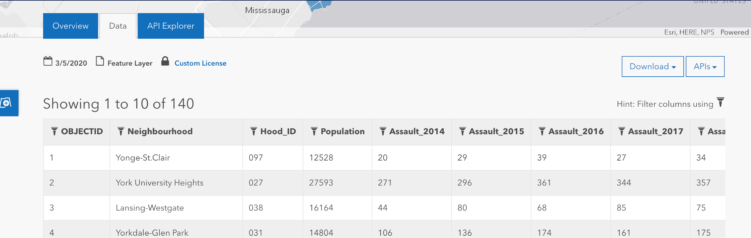

Add layers:

* Each crime?
* Have night and day switch?
* Tooltips with info
* Each area/neighborhood/region? -> zoom in/out of neighbourhood on click if possible? <https://leafletjs.com/examples/choropleth/>

Scatter Plots

* Rank neighbourhoods
* Good way to show safe/unsafe on a graph

Bar plot to show total crimes (can filter by areas)

* This way you can see what crimes are bad in your neighbourhood

